**Regression Analysis**

**Rolls-Royce Weekly Excess Returns against Market Weekly Excess Returns**

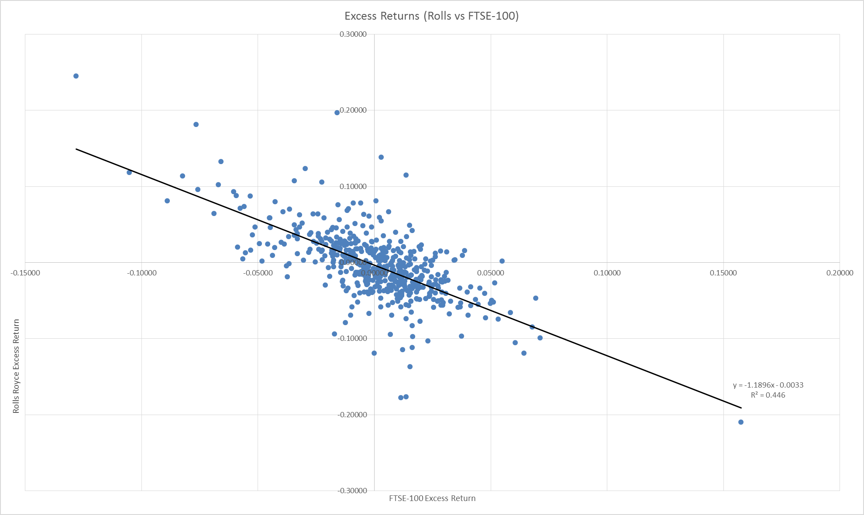

This graph was created by computing the excess returns of both the Market (FTSE 100) and Rolls Royce. The method used was as follows:

Weekly returns for Rolls-Royce, the FTSE 100 and Government bonds were calculated using the formula:

$${HPR}_{t}= \frac{P_{t}+Income- P_{t-1}}{P_{t-1}}$$

These weekly returns are shown in Appendix X.

Following this, the Government bonds were used as a proxy for the risk free rate, and therefore subtracted from each weekly return for Rolls-Royce and the FTSE 100, giving two columns of excess returns, shown in Appendix X.

The excess returns for the company were plotted on the y-axis and the excess returns for the market (FTSE 100) on the x-axis.

The regression results are given below:



The gradient of this graph shows the variation of Rolls-Royce returns against Market returns i.e the Beta (β). Hence, the (β) for Rolls-Royce is -1.190 (3 s.f.). It can be seen from the graph and the β value, that there is negative correlation between Market returns and Rolls-Royce returns. This means that as the market rises (falls), Rolls-Royce returns will fall (rise). The company is therefore heavily underperforming in the market, and such a stock is said to be aggressive. To illustrate this, we will consider the following example. Suppose the market return premium rises by 10%, the return premium on Rolls-Royce equity will fall by -11.9%. The reason for this result is…..

Another feature of the regression results is R2, which represents systematic risk (the risk to the entire market) and is non-diversifiable. The value obtained is 0.446 (3 s.f.). Hence, approximately 44.6% of the “riskiness” or the variation in returns of Rolls-Royce stock is due to market variation, suggesting that Rolls-Royce stock follows market conditions reasonably closely. The non-systematic or firm-specific risk is therefore given by 1-R2. 1-R2 = 1-0.446 = 0.554. Therefore, 55.4% of the riskiness of the firm is due to firm specific factors. This element of risk is diversifiable.

**Security Market Line (SML)**

The SML is essentially a graphical representation of the Capital Asset Pricing Model (CAPM). It is a straight line graph, plotting individual security returns against their betas, and has the formula:

$$E\left(R_{i}\right)=R_{f}+ β_{i} [E\left(R_{M}\right)-R_{f}]$$

where

E(Ri) = Expected return on security i

Rf = Risk free return

βi = Beta of security i

E(Rm) = Expected return on market portfolio

The risk free rate was calculated by taking the arithmetic mean of the weekly returns of Government bonds and compounding it weekly for one year (t=52):

[(1 + (sum of weekly Government bonds returns/number of entries (515)))^52] – 1

(1 + (0.4051/515))^52 - 1 = 0.0417

0.0417 x 100 = 4.17% (Rf).

The expected return on market portfolio (E(Rm)) was calculated taking the arithmetic mean of the weekly returns of the FTSE 100 and compounding it for one year:

[(1 + (sum of weekly FTSE 100 returns/number of entries (515)))^52] – 1

(1 + (0.897866/515))^52 - 1 = 0.094784

0.094784 x 100 = 9.48% (E(Rm)).

The SML is plotted using this data:

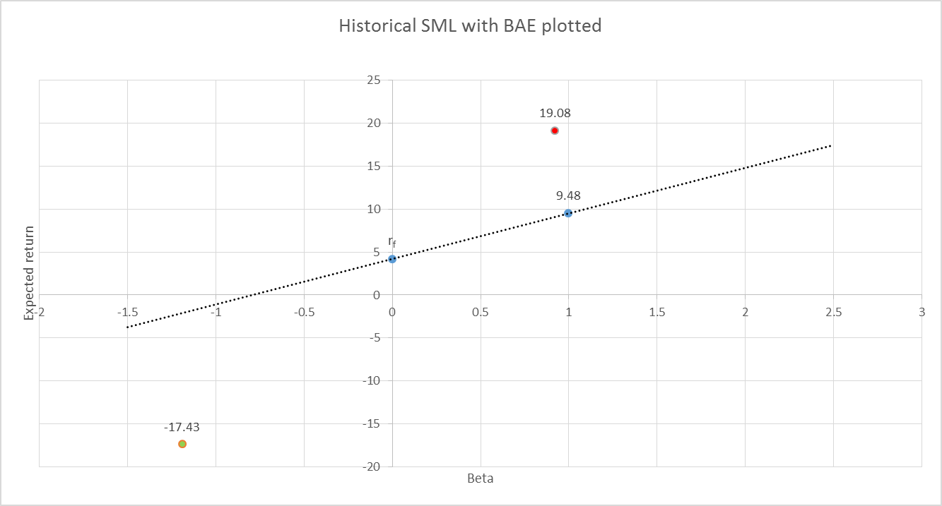

The expected return for Rolls-Royce stock can now be calculated:

$$E\left(R_{i}\right)=R_{f}+ β_{i} [E\left(R_{M}\right)-R_{f}]$$

$$E\left(R_{i}\right)=4.17-1.190 [9.48-4.17]$$

$$E\left(R_{i}\right)=-17.43\%$$

The yellow dot on the graph represents Rolls-Royce expected return, and it is clearly situated below the SML, rejected CAPM theory. This means the stock is underperforming, since the expected return is lower than would be predicted based on the risk associated with the stock. Therefore, the stock is overpriced.